Patrick McGrath

11/6/2015

Prototype 7

1 View of grades.html:

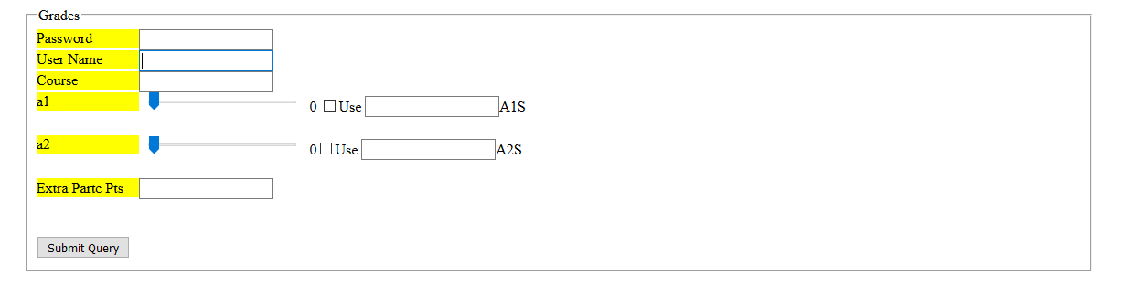

2 html for grades.html:

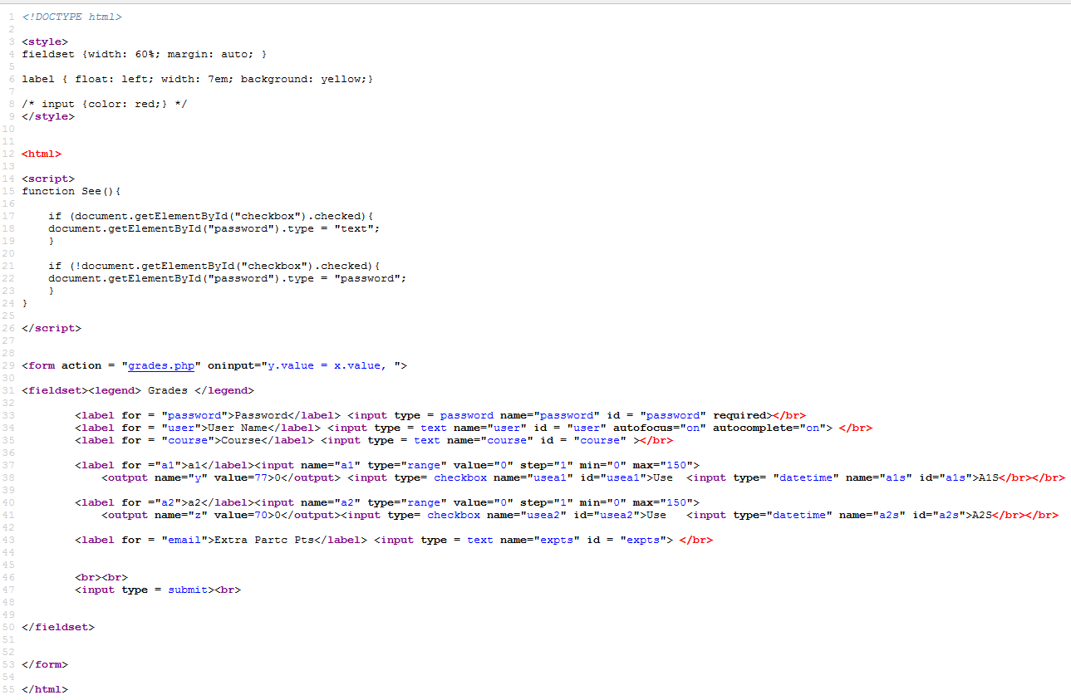

Grades. Php:

